Investigation 13B: Weather Forecasts

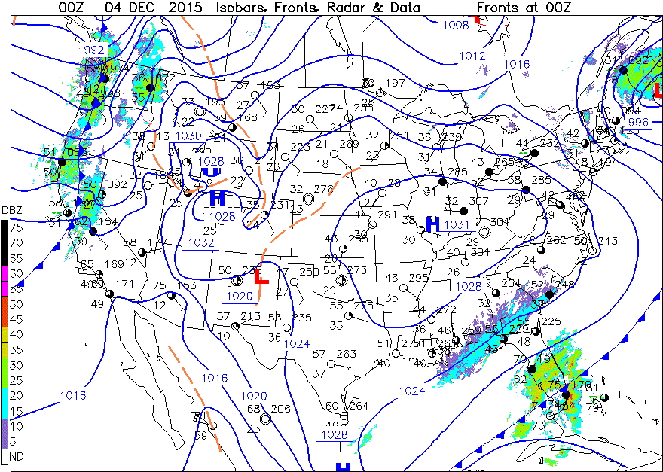

1. "At map time, national conditions depicted on this surface weather map showed that generally there was (were) ________."
- an area of precipitation from eastern Maine into the Canadian Maritimes
- fair weather from the East Coast to the Rocky Mountains
- precipitation scattered in Washington, Oregon, and northern California
- precipitation from Louisiana to South Carolina and over southern Florida
- all of these situations

2. "The Figure 1 weather map showed the Pacific coast states generally being influenced by a ________ frontal system."
- warm
- stationary
- cold
- occluded

3. "The general eastward movement of weather systems ________ suggest that the precipitation across the West Coast of the country might move past the mountains and into the central U.S. in the next couple of days or so. Perhaps another storm system will replace it however."
- would
- would not

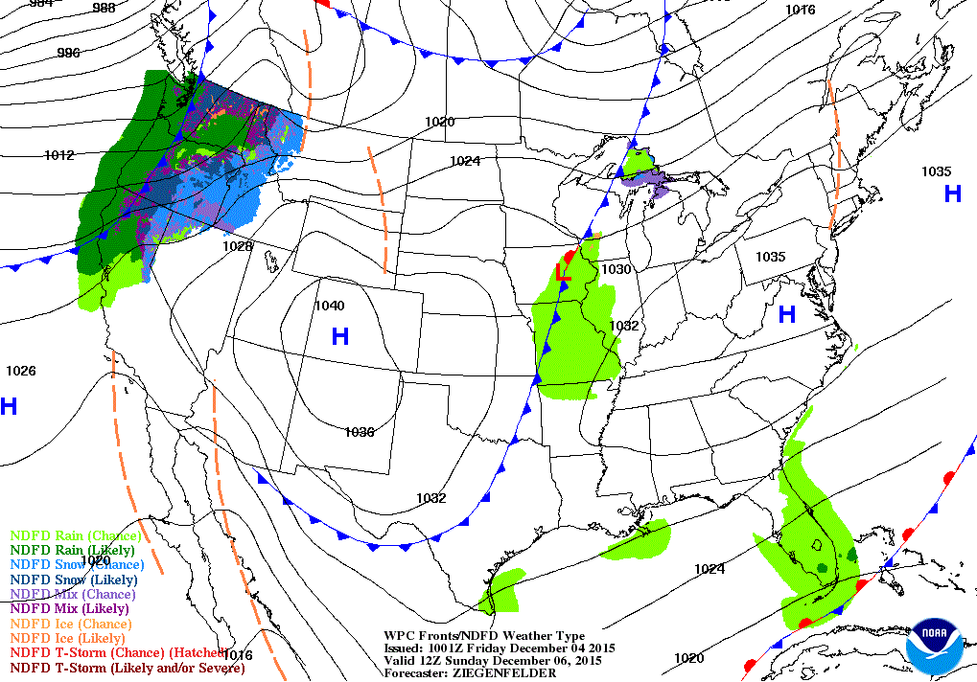

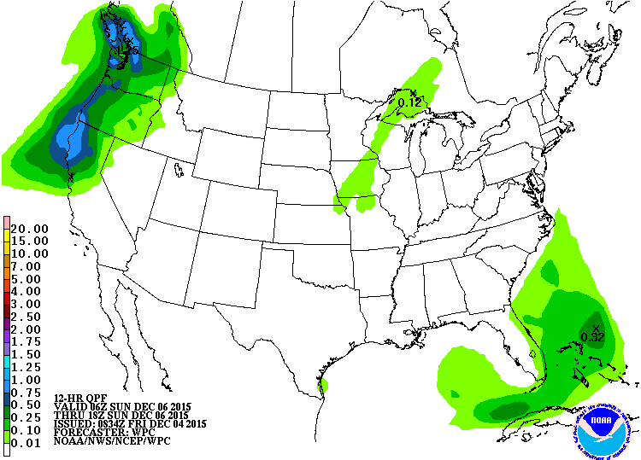

4. "Figure 2a shows a cold front and light rain has moved in to the north-central U.S.. This is forecast to be the location of the Figure 1 West Coast front at the valid map time. The Northwest coast area is expected to be influenced by a ________ at 12Z 6 December 2015 (4 AM PST). This system traveled from the Pacific Ocean off the map area to the coast over the two-day interval between Figures 1 and 2a."
- cold front
- warm front
- high-pressure system

5. "From Figure 2a for the Washington-Oregon-northern California area at 12Z 6 December, there is a likelihood of: ________."
- rain or thunderstorms
- expansive clear skies

6. "From the Figure 2b interval shadings, the northern California coastal area could expect to receive up to ________ inch(es) of precipitation during the 12-hour period ending at 18Z 6 December 2015."
- 0.01
- 0.3
- 1.0
- 2.0

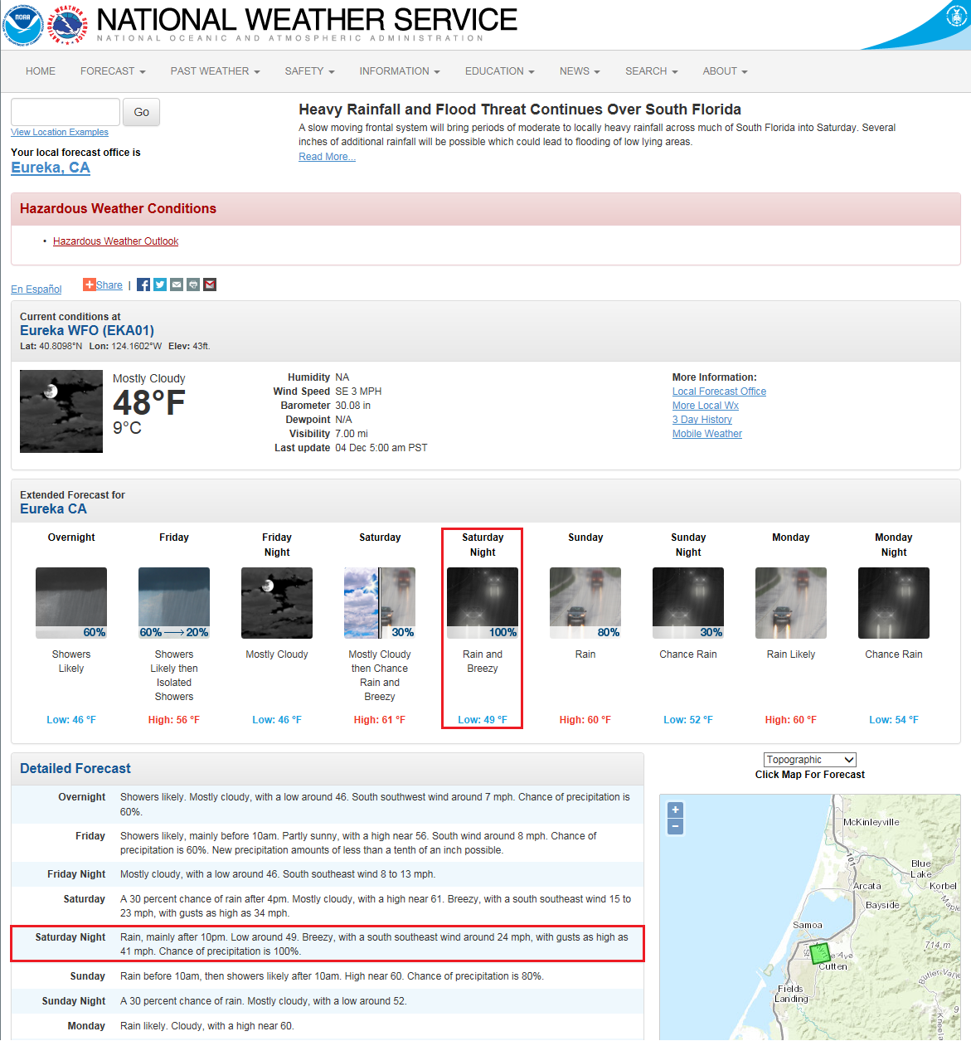

7. "The small graphical depictions cover a period of approximately ________."
- one day
- five days
- seven days

8. "The graphical forecasts section is generally divided into ________ segments."
- morning and afternoon
- day and night

9. "In the Figure 3, Detailed Forecast (text) section, the forecast weather conditions during the first two days of the seven days of forecasts routinely include, in addition to information provided in the graphical forecasts segment, ________."
- wind
- probability of precipitation
- both of these

10. "Saturday night low temperature is forecast as: ________ °F. (Actually, this will probably occur early on Sunday morning.)"
- 49
- 53
- 61

11. "Cloud cover (given the likely weather situation noted): ________."
- clear
- partly cloudy
- cloudy

12. "General probability of precipitation as high as: ________."
- none given
- 30%
- 70%
- 100%

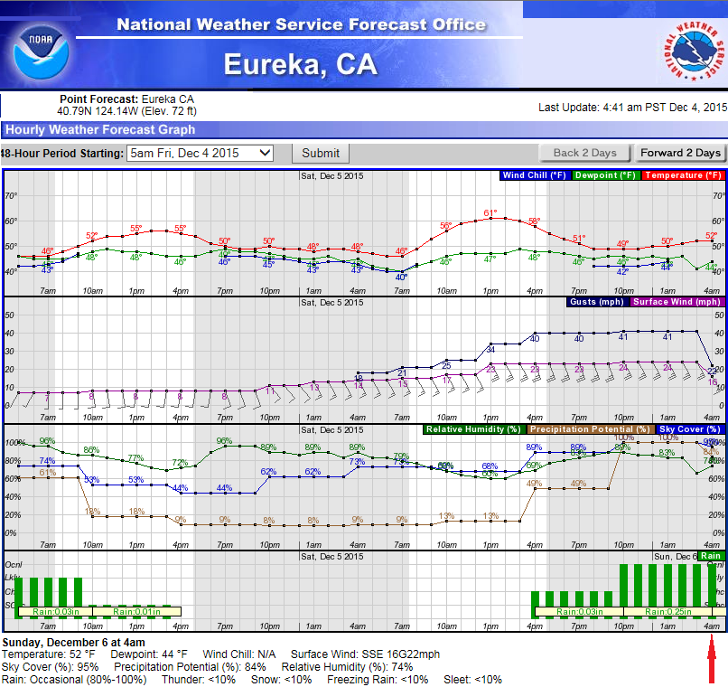

13. "Figure 5 is the partial forecast webpage for Eureka, CA, on Sunday morning showing the weather conditions at 3:53 AM 6 December 2015 highlighted in the green box. The temperature at that time was ________ °F."
- 49
- 52
- 57

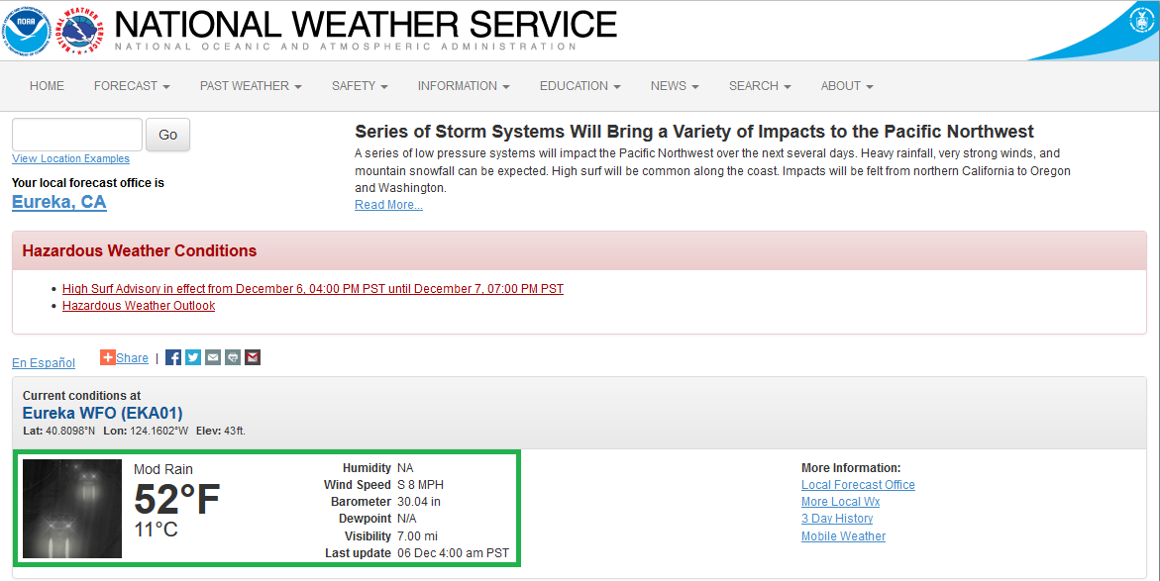

14. "The wind was from the S at ________ mph."
- 5
- 8
- 13
- 17

15. "The current weather condition was ________."
- snow
- moderate rain
- fair, sunny
- overcast (cloudy)

16. "From the 3-day History link, the accumulated precipitation amount between 06Z and 18Z on 6 December 2015 (not shown) was 0.22 inches. Compare this to the amount displayed in the forecast precipitation map in Figure 2b. Figure 2b showed moderate blue shading over Eureka, meaning forecast precipitation between 1.00 to 1.25 inches. The actual precipitation amount received ________ less than the forecast limits from two days prior. However, precipitation did occur in a reasonable amount during that period."
- was
- was not

17. "Compare the forecast temperature, wind, sky, and precipitation conditions with the conditions that actually occurred two days following as given in Figure 5. These values ________ generally useful to provide useful guidance for planning activities. General planning for several days into the future for many activities and events calls for necessary preparations to minimize damages and excessive costs; these forecasts would provide such information."
- were
- were not

Applications

18. "Go to: http://www.weather.gov/ (). Find your location (or your favorite location) on the National Weather Service interactive map and click on it. The resulting webpage shows the local NWS forecast office’s (location listed below the “headlines”) area of responsibility for issuing weather warnings and forecasts. From the regional map, click on your approximate location. Examine the forecast products that are displayed. Under the graphical forecasts of the next few days are plain-language forecasts. These text forecasts are presented out to ________ days in the future."
- 3
- 5
- 7

19. "Scroll down the page and click on one of the thumbnail maps for the National Digital Forecast DataBase. The “Daily View” tab shows maps can be advanced or backed within each 12-hour period for the length of the forecasts presented in text. Individual maps for most weather elements (e.g., temperature) are shown at ________ hour intervals within each period. Some products are for longer periods and there are tabs for choosing a Weekly View or for Loops. The looping feature can be used to produce a vivid display of diurnal temperature cycles or day-to-day changes as weather systems pass."
- 3-
- 6-
- 12-

